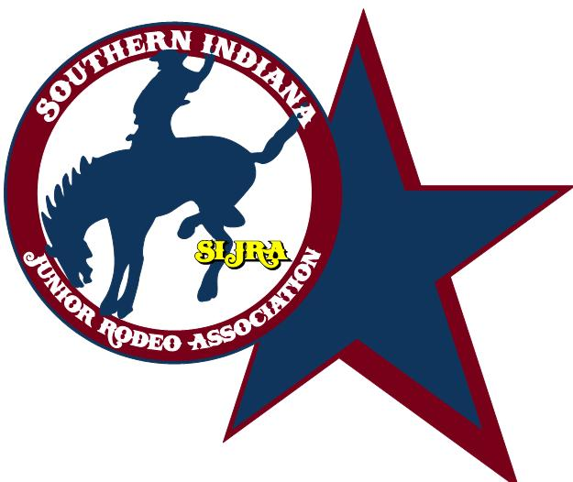 **Vendor Set-Up Agreement**

Thank you for your interest in bringing your products to our association. While we want to welcome everyone without creating too many restrictions, we want to keep continuity between all interested parties. Ultimately our first interest is with the kids, so we also want to be sure it benefits all of them. Please read through the following information and contact a board member if you have questions:

As an individual requesting permission to sell items at the Southern Indiana Junior Rodeo Arena, Salem, IN, I agree to abide by the following criteria:

- Keep my area contained to a simple, temporary pop-up tent and provide my own tables, chairs etc. Set up the night before a rodeo is allowed if that is helpful but the tent must come down shortly thereafter. The tent must also be set up in an area designated by the board and will not be against the arena.

- Provide information regarding my intentions and product line for the board to review. No vulgar terms, alcohol or tobacco references please.

- Disclose what percentage or lump sum I intend to give back to the association for this opportunity. A minimum of a $25 per site per day fee is required. What you would like to offer back to the association over and above the day fee is up to the vendor.

- Agree not to compete with products that are already being sold by the association such as T-shirts, ropes etc.

- Indicate which rodeos you would like to set-up at so we can help you if necessary. Again, thank you for your interest. The SIJRA is glad to have you!

Signed: Date: