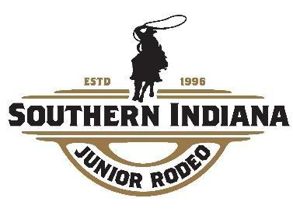
2024 SIJRA PRE-KINDERGARTEN CHECKLIST
No age minimum

Forms are available at www.sijra.org

2024 Rodeo Dates:
May 25, May 26, July 6, August 17, September 14, October 12, October 13

Start time: Upon completion of K-1-2 Dummy Events in the Lil’ Cowpokes Arena
Approx. 9:30 a.m.

Pre-K Events:
Grand Entry - Walk in the arena from the side gate
Dummy Steer Roping
Dummy Calf Roping
Dummy Goat Tying
Barrel Racing on the pattern on a Stick horse
Pole Bending on the pattern on a Stick horse

The following forms needs to be turned by/at your first rodeo:

_______ Membership form along with $15 membership fee

_______ Accident Waiver/Release of Liability Form

_______ Participate in at least 3 rodeos for the 2024 Season to be eligible for the year-end award

________Optional: Rodeo Sponsorship Form by your third rodeo.
(Sponsorship money is NOT required for Pre-K contestants, however a Pre-K contestant will be eligible for the same membership award as the K-8 contestants with a $100, $300, $750 or $1,000 sponsorship.)

